



METU EEE

STATIC ENERGY CONVERION-I

HARDWARE PROJECT REPORT

Yunus Cem Duman-2093680

Mert Aydın-2093334

Burak Kemal Kara-2114734

**Date:15.01.2020**

Table of Contents

1. Introduction 3

2. The Description and The Aim of The Project 3

3. Design of the Project 4

3.1. The Main Topology 4

3.1.1. Three Phase Rectifier 5

3.1.2. Buck Converter 7

3.1.3. Logic Circuit 9

3.2. Thermal Design 11

3.3. The Implementations for Bonuses 20

3.3.1. H-Bridge 20

3.3.2. PCB Implementation 23

3.3.3. Industrial Box 25

3.3.4. Closed-loop Voltage/Current Control by Arduino 26

4. Conclusion 31

5. References 31

# 1. Introduction

The demand for the electrical power over the world increased by increasing population. Electrical vehicles, smart houses, wind trubines etc. , which has inevitable to improve by this increasing population, has made a great influence on the power systems and changed the traditional understanding of power system. These developments made the power systems and power electronics area much more important than before. These areas are completes each other. However the project is more about the power electronics area. The power electronics area has a huge scope of electrical engineering.This area contains rectifiers, inverters, DC/DC converters, motor drive circuitries, electrical vehicles, generators, motors etc. These circuitries are commonly used in our daily life and it is developing everyday. In order to understand and contribute the developments at this area, it is essential to have a good understanding of basic topologies of this area. So this project is all about having an understanding of one of the very basic applications of the power electronics area.

This project is a work of full understanding of DC motor drive. The main idea is to drive the DC motor that is applicable at laboratory, by using a variac, the device for arranging the voltage level that is taken from the grid and control the DC motor’s speed. The drive circuitry is a combination of some of the topologies that this discipline covers such as rectifier circuitry and DC/DC converter etc.

# 2. The Description and The Aim of The Project

The project is to design a DC motor drive that is applicable at laboratory and can be seen at Figure 1.

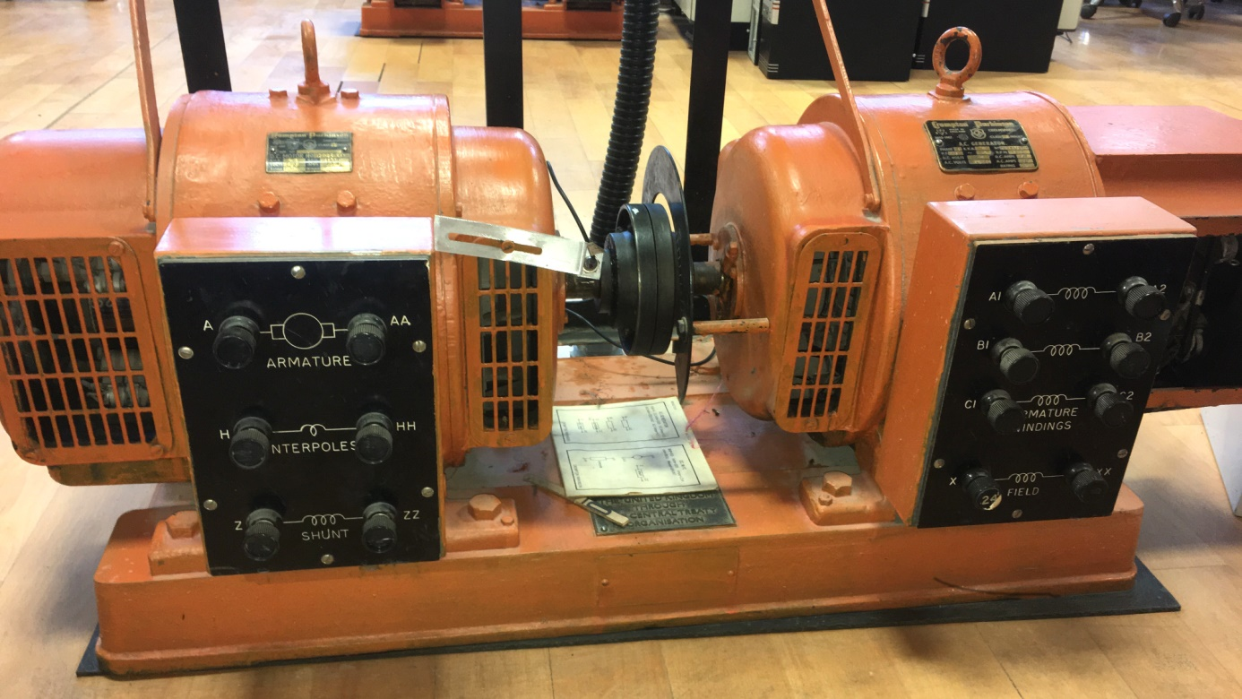

Figure 1:The DC Motor(Crompton Parkinson brand)

This motor is an experimental type motor and it’s rating values can be seen from the below figure.

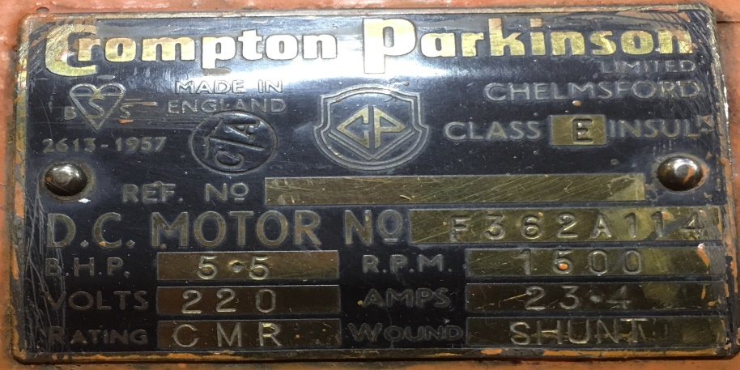

Figure 2:The Ratings of DC Motor

The motor has;

**-Armature Winding**: 0.8 $Ω ,12.5 mH$

**-Shunt Winding**: 210 Ω, 23 H

**-Interpoles Winding**: 0.27 Ω, 12 mH

**-Inertia**: TBA

In order to drive this DC motor many circuit topology can be used. However due to simplicity and applicability of the diode rectifier and a buck converter connected topology is choosen which can be seen at Figure 3.

# 3. Design of the Project

## 3.1. The Main Topology

The main topology of the design is a three phase diode rectifier and a buck converter. The main working principle of the drive can be examined one by one. Firstly three pahse diode rectifier converts the AC voltage that is supplied by variac and converts it to DC voltage. Changing the variac voltage in order to control the speed of the motor is restricted. So it is impossible to control the DC voltage applied to motor by just using three phase diode rectifier. So the buck converter is used in order to control the DC voltage level that is applied to DC motor. According to the duty cycle applied to the switch (MOSFET) of the buck converter topology, can be seen at Figure 3, the voltage level that is applied to DC motor can be controlled. So that means another circuitry is necessary to drive the MOSFET also. So 555 timer is used in order to drive the mosfet of the buck converter. However that was not enough either. 555 Timer circuitry can not drive the mosfet circuitry alone, so octocoupler circuitry is necessary.

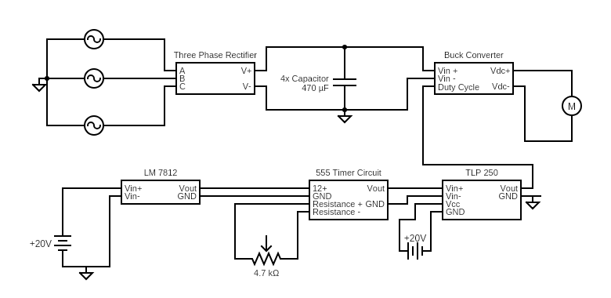

Figure 3 Overall Hardware scheme

Overall hardware scheme concludes how circuit works to drive motor. Circuit divide into 3 main part, Three phase rectifier, Buck converter and Logic circuit.

### 3.1.1. Three Phase Rectifier

In order to control the voltage at the input of the buck converter we should first convert ac signal into some form that we can extract some d.c signal from it. Therefore, we have decided to used 3-phase full bridge rectifier. Because it can provide higher voltage compared to half and single phase ones, there will be a wider range at the input of the buck converter to control that voltage. for the commercial product we choose “SBR 3516” it can conduct 38A and bear Vrrm=1600V its ratings are really good for our puırposes. That product is a complete bridge rectifier in other words, we did not deal with single diodes to form an full bridge rectifier so, it provides an easy implementation and compactness in the circuit also, we use some golden foot (see fig...=) to embed that module to the stripboard because in that way we can simply pull and push the module easily to that place. Finally, its advantageous in terms of the filter component size because its output voltage frequency is six times of its input frequency and that provides higher fundamental harmonic to eliminate which easier than lower one.

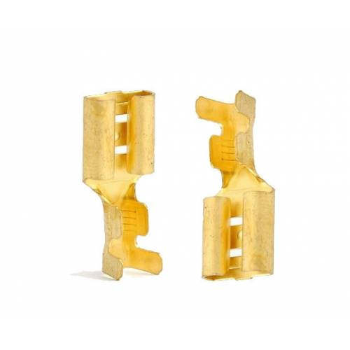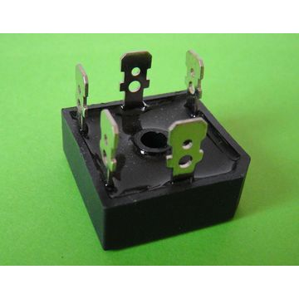

Figure 4 : the figure of the golden foot and SBR-3516 module.

**Some theoretical calculations for rectifier**

(*) VOUT=1.35RMS

(**) fOUT=fin*6

**Test result for bridge rectifier**

In order to test the rectifier module we simply connect it without any load and observing its ripple by a oscilloscope probe. As can be seen from the figure below, we have 220 mV ripple however we take this measurement in AC coupling mode. Therefore, mean voltage does not seem at same screen however it corresponds to 193V mean voltage according to measurements obtained from multimeter.

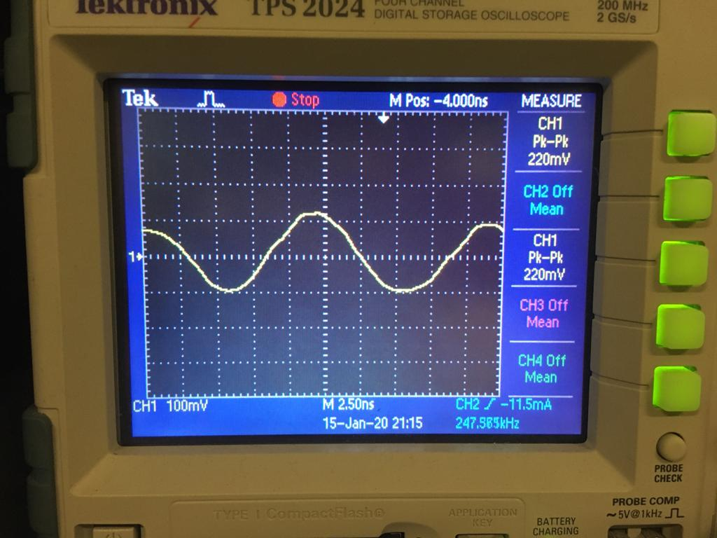

Figure 5: the ripple of the output of the full bridge rectifier.

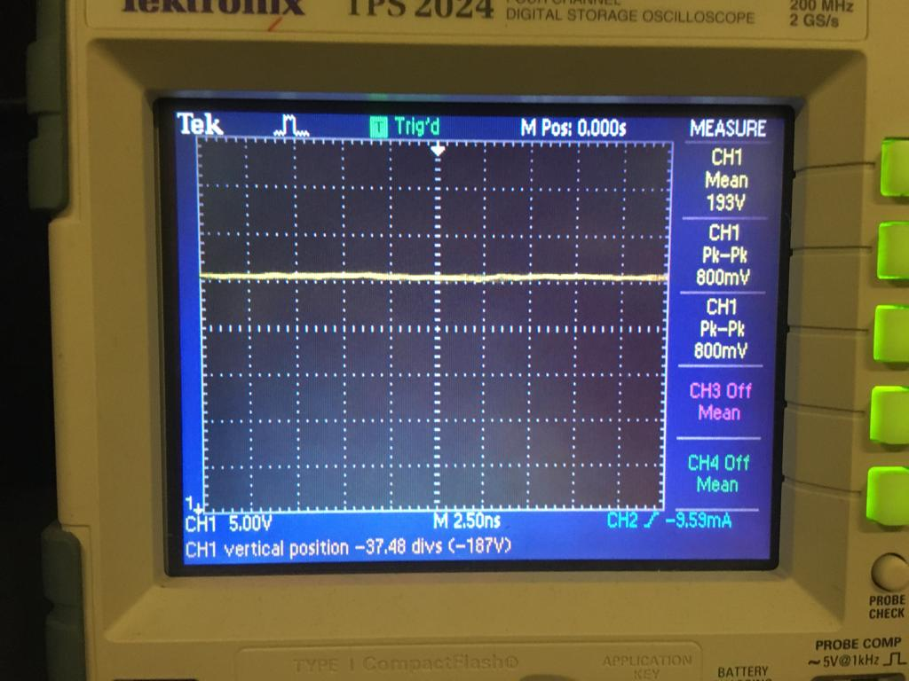

Figure 6: the output of the full bridge rectifier measured at DC coupling

(note: peak to peak value can not measured at that Voltage scale because it is hard to see for the oscilloscope to obtain data at that big scale)

### 3.1.2. Buck Converter

It also named as step down DC-DC converter. By using property of duty cycle average voltage at the output can be configured. Since Output votlage of Buck converter is,

$$V_{o}=D∙V_{in}$$

Motor voltage is adjustable. Detailed buck converter scheme is show at figure 7.

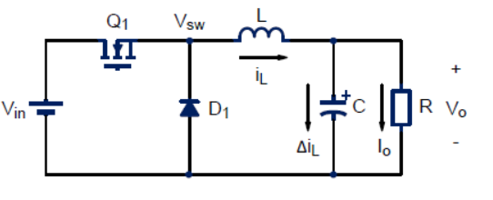

Figure 7 Common buck converter topology (high side switching)

We change two things in this circuit,

1. Remove Capacitor and Inductor

Resason of removing Capacitor and inductor is since motor acts like a very large inductor, Current is already supplied to load.

1. Position of switching component.

If we use switching compnent as shown at Figure 7, we also need a floating voltage source. Because emitter terminal of IGBT is also changing at each step. Driver circuits voltage should be referenced according to emitter voltage of IGBT. When switching component use at low side as shown at figure 8, ground can be taken as a reference. There are 2 important component to select. IGBT and Diode.

According to simulation result at Figure 9, Max current of Diode is 8A and max power of IGBT is 2kW with 300V at steady state in no load. Taking into account, by load this values increase we choose,

|  |  |  |
| --- | --- | --- |
| Selected Components | Max Current | Max Voltage |
| DHG30I600PA Diode | 30 A | 600 V |
| IXGH24N60C4D1 IGBT | 30 A | 600V |

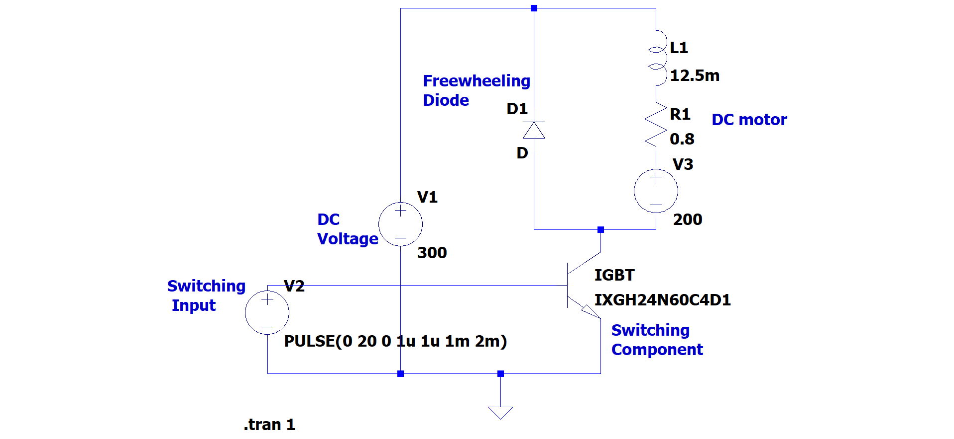

Figure 8: Altered Buck converter (Low Side)

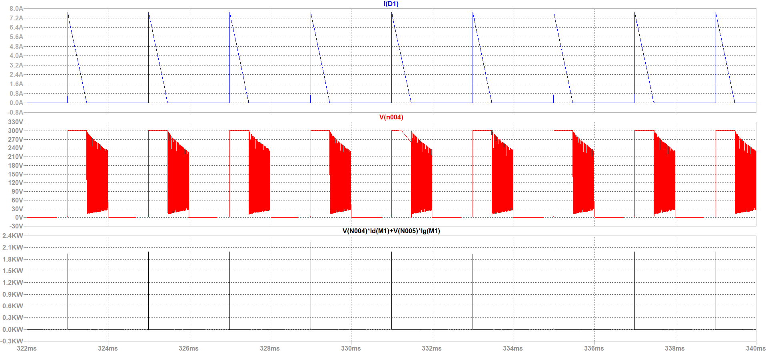

Figure 9: Max current of Diode and Power and voltage measurent of IGBT

After testing real result is,

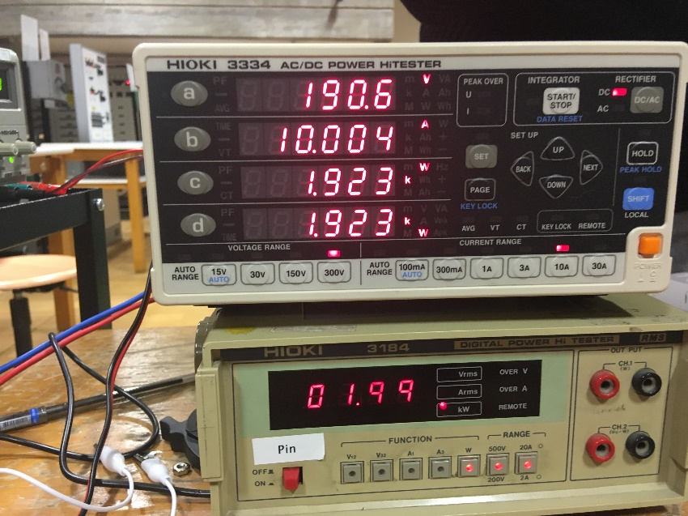

Figure 10: Circuit measurement while driving load

As seen in Figure 10, selected compenents can resists 1.9kW and 10 A.

### 3.1.3. Logic Circuit

We use only 1 dc supply as 20V. This voltage is higher than rated voltage of 555 Timer. To use 555 timer safely, LM7812 convert 20V to 12V.

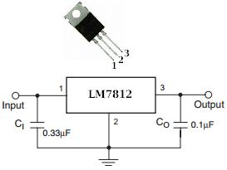

Figure 11 LM7812 low power voltage regulator

LM7812 rated current is 1A. 555 timer draws less than 200mA in worst case, so this regulator works perfect.

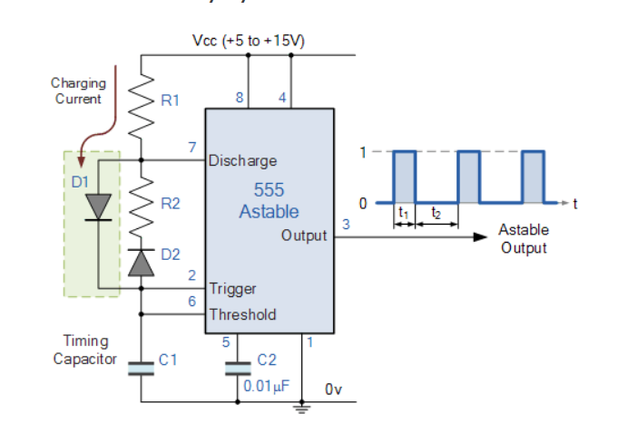

Figure 12: Timer 555 Astable

Timer 555 used in astable mode to ensure variable duty cycle with 500Hz.Note that D1 assures full duty cycle can provided. For this design,

C=220nF

R1=5k

R2=5k POT

For example, assume R2 POT is fixed at 4k.

$$f=\frac{1.44}{(R_{1}+R_{2})∙C}=503Hz$$

$$Duty Cycle=\frac{R_{1}+R_{2}}{R_{1}+{2R}_{2}}=\%69$$

Note that R2 is also changed frequency but as long as it does not fall too low frequency it is not a problem. For this kind of operation, frequency range is 440Hz-1kHz.

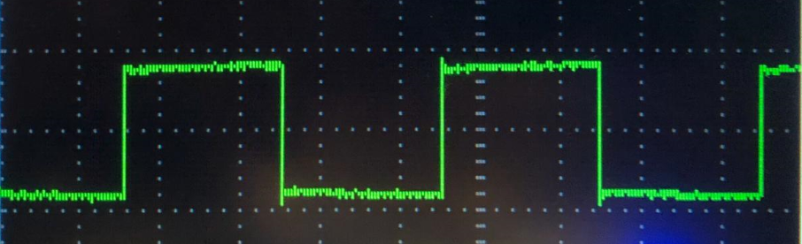

Figure 13: Example Output of 555 Timer

This Pulse should be given to IGBT in the buck converter. To activate Gate of IGBT 555 Timer cannot supply high current to charge IGBT capacitor. To isolate timer circuit and supply high current TLP 250 used. TLP 250 is an isolated IGBT/Mosfet driver.  The input side consists of a LED. The output side gets a drive signal through an integrated photodetector. Therefore, the main feature is electrical. It transfers electrical signals optically via light. Since it is rated Vcc is 35V using 20 V in is not problem for TLP 250. Also input and outout gnd is common ground because we use low side IGBT. TLP only supports high current and isolation.

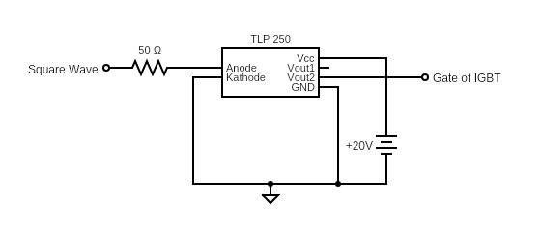

Figure 14: TLP circuit

## 3.2. Thermal Design

Thermal design one of the most important considerations in the power electronic circuits because there a lot of power handling electronic components and unfortunately, these devices does not work at %100 efficiency. Therefore, some of the losses should be dissipated as heat through these components. However, these devices can not tolerate that much heat by itselves. Thus, additional mechanical parts should be integrated with them to ease the dissipation of the heat. Additionally, not just because the safety of the components, but also, performance and life-time of the components are mostly determined by thermal design so, it should be implemented for those reasons.

For our circuit, there are two parts that dissipate heat significantly, These are rectifier unit, and buck converter. Since we have one compact rectifier module and also diode and mosfet which form buck converter connected to same heatsink, two heatsinks are used totally.While selecting heatsinks, not just driving at no load is considered but also robustness bonus is considered. Therefore, calculations are made for both requirements as follows.

**Calculations:**

For the first, the heatsink for buck converter is calculated

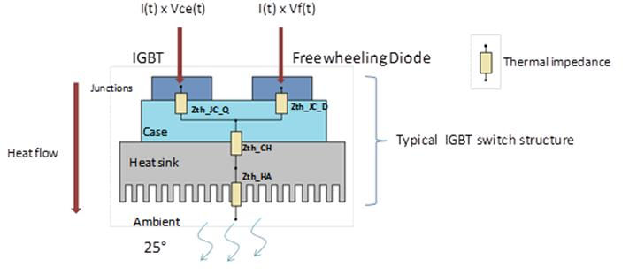

Figure 15: thermic lumped parameter model of the buck converter.

* First we assume the thermal contact between the heatsink and component are neglible so, we neglect that part.
* Secondly, we should calculate total power loss to select the suitable heatsink.

For that purpose, we should look back to datasheet of the diode and IGBT to obtain the pararameters for both conduction losses and switching losses.

firstly , we use DHG30I600PA diode and its parameters are as follows:

**(*) V**fo=1.17V.

(**) rF=32 mΩ.

And for the Switching losses,

$Ps=Qr×Vr×fs$ (we already know the fs=500Hz and Vr =200V at most)

We just need to find Qr from following graph.

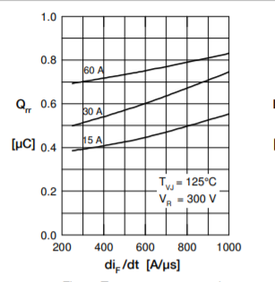

Figure 16: Qr vs dif/dt from datasheet.

From above figure we Assume Qr as 0.3 uA at worst situation because the current that pass through the diode never exceeds the 10A.

So, we can insert those values to the equations,

Pcd= (1.17 $+10×$ 0.032) $×$ 10 $≈15 Watt$ (we assume at most diode conduct 10 A which is still lover than rated operation of the project

Psd=0.3 $×200×500×1{0^{}}^{-6}≈$ 0 (since frequency is low it is normal)

Psd+Pcd=15 Watt at total contribution from diode.

Now we can calculate the losses for the IGBT.

For the conduction losses of IGBT,

**Vce**=1.6 V (collector emitter sat. voltage)

**If=**10 A ( for a safety margin. normally it depends on duty cycle)

Pic= 16 Watt .

For the Switching losses, we should obtain the energy required for opening and closing.

We choose the “IGW30N60T” IGBT and from its datasheet, ETOTAL=1.8 mJ

the frequency of operation is around 500Hz and that energy will be given and taken in one interval of operation. Therefore, we should multiply fS with the ETOTAL to find switching loss.

Pis=fS (it expected since frequency is so low)

Therefore, total contribution from IGBT is 17 watt.

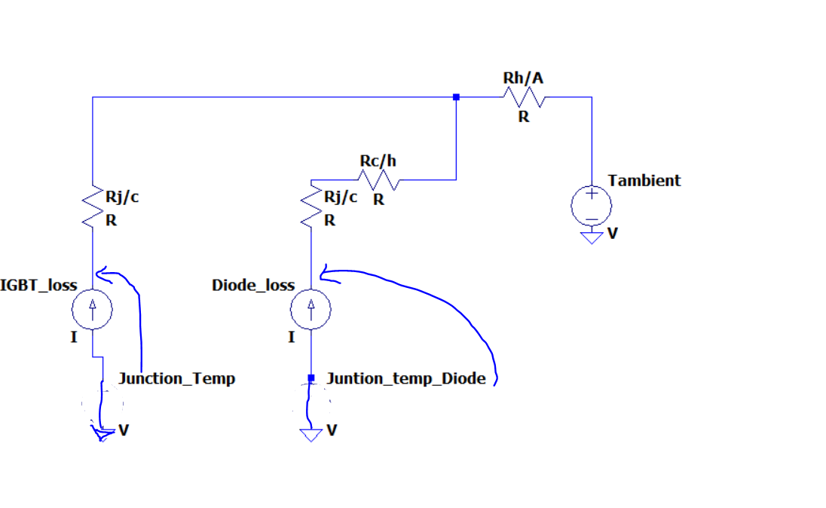

Figure 17: detailed lumped model of thermal design.

* Thirdly, we should find the thermal resistances from the datasheets and guessing a reasonable heatsink value from these results.

**Rj/c(diode)=0.7 C/W , Rc/H(diode) =0.5 C/W Rtotal=1.2C/W**

**Rj/c(IGBT)=0.8 C/W**

if we assume heatsink has 1.0 C/W thermal resistance then the junction temperatures will become as below:

Tj(diode)=25+15 $×1.2+$ 32 $×$ 1=75 C.

Tj(IGBT)=25+17 $×$ 0.8+32 $×$ 1=70.6 C.

These are far less values that the maximum operating junction temperature which is 175 C degrees so, we select a heatsink which has 0.9 C/W thermal resistance to realize the that idea.

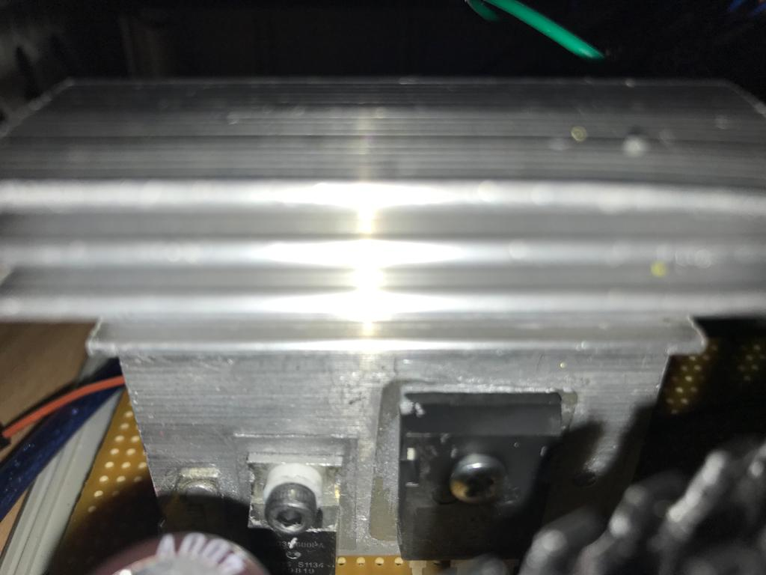

Figure 18: Resultant hardware configuration of thermal design (for buck converter)

For the Second, we will calculate the heatsink required for the Three-phase full bridge rectifier,

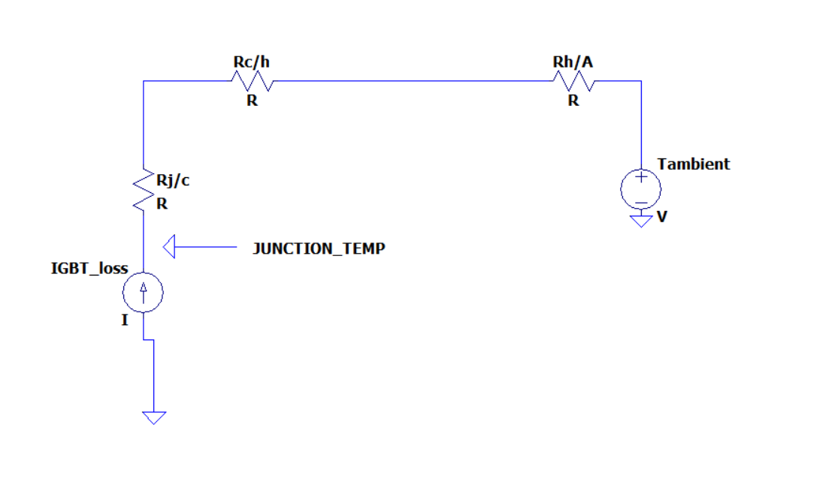

Figure 19: The detailed lumped model of the bridge module.

So, Again we should calculate the losses and applying the same procedures above for the selecting a suitable heatsink.

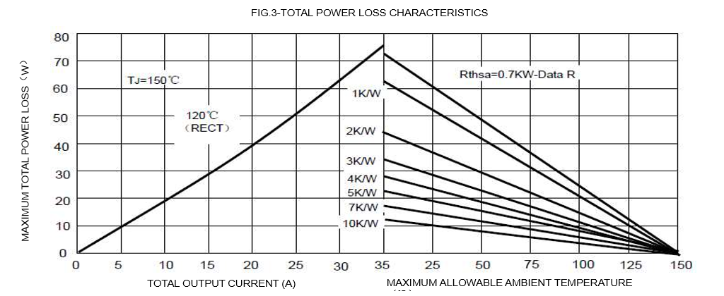

Figure 20: power loss characteristic of the bridge module. (from datasheet)

Since we have a bridge module rather than six single diodes, accessing the datasheet of the diodes inside of the module is not possible. In datasheet provided for complete module includes some general power loss characteristic as in the figure above. this curve gives the maximum power loss therefore, it will be safe to use it although it may results with unnecessarily large heatsink.

Ploss= 20 Watt (at 10A output).

So, it is now time to find thermal parameters from the same datasheet.

**Rj/c**=1.16 C/W.

**Rc/h=**0.2 C/W.

So, we try with a 1.8C/W heatsink and result will be:

Tj=(1.16+0.2+1.8) $×$ 20=88 C

So, it is again relatively safe for the operation of this project.

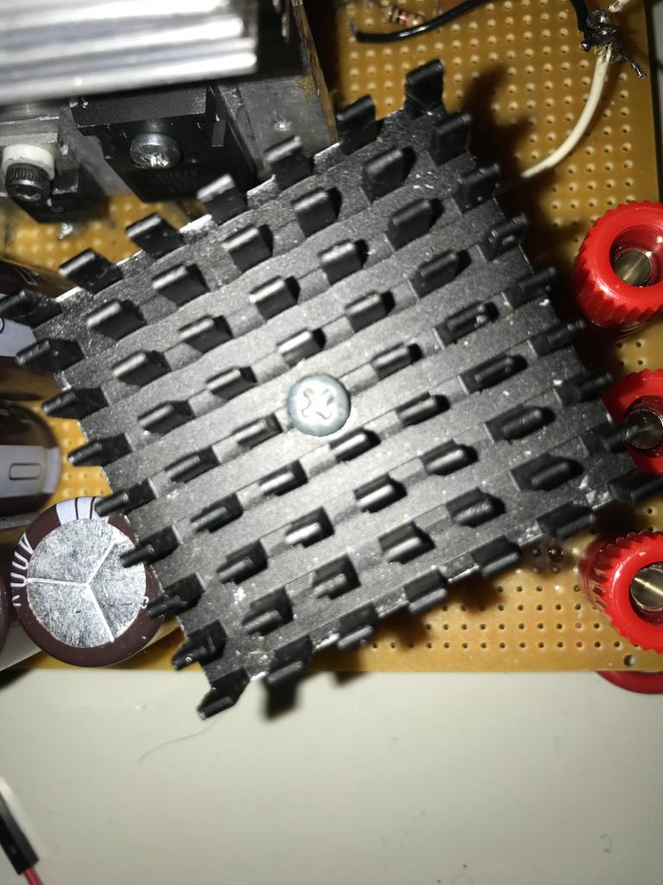

Figure:21 the heatsink for the full bridge rectifier.

**Test results for the Thermal design**

We have tested our circuit with constant R-L load. The current changes approximately in the range of 3A-4A. we take the data for the initial conditions and we start our driver circuit. After adjusting the duty cycle to obtain constant average current we simply record the thermal camera values at some interval.

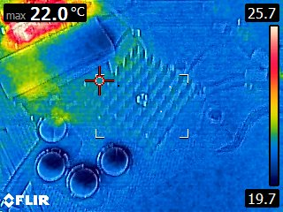

Figure 22: data taken from the initial condition.

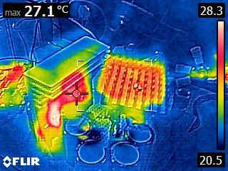

Figure 23: thermal data

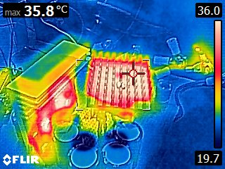

Figure24: thermal data

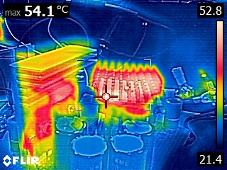

Figure 25: thermal data at near the steady-state

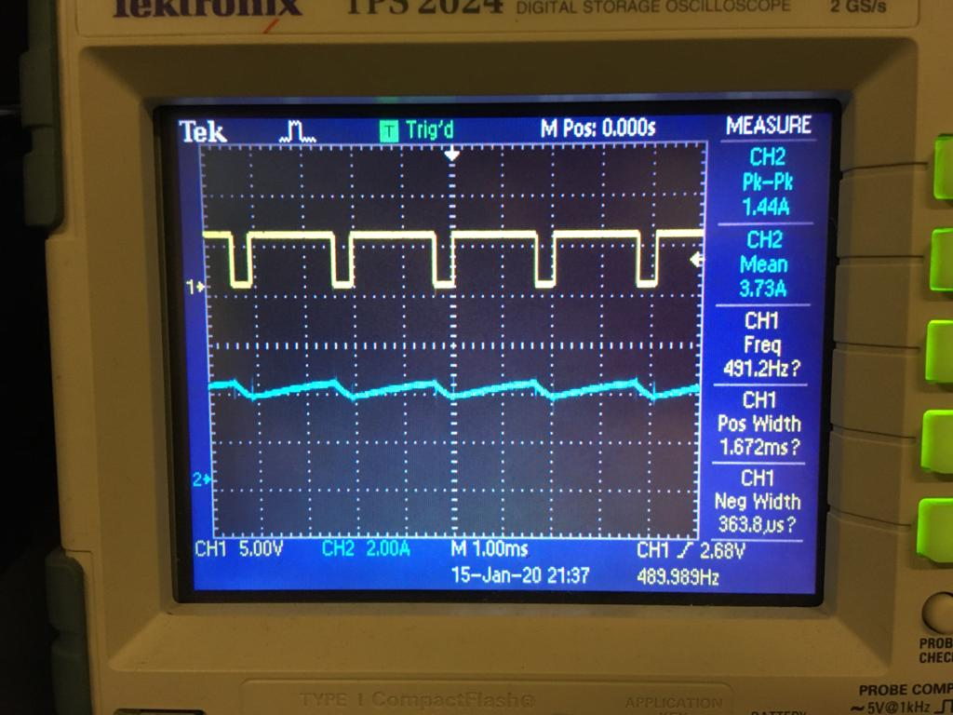

Figure 26: Testing conditions.

**Final Comment:** The thermal design is calculated for the 10 ampere input current with %100 duty cycle case however test is done with approximately 4 ampere output current and since duty cycle is not %100 mosfet and diode currents are probably lower therefore it is normal to have lower temperatures for testing condition and to conclude our design and test results are correlated and it shows its success.

## 3.3. The Implementations for Bonuses

### 3.3.1. H-Bridge

H-bridge is using to have 4 quadrant operation of DC motor. Logic of H bridge is explained by visually.

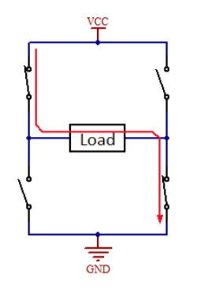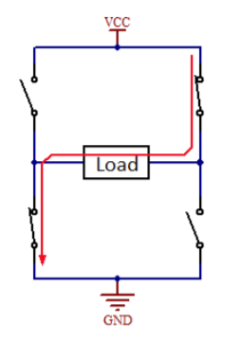

Figure 27: Motoring in forward direction and reverse direction

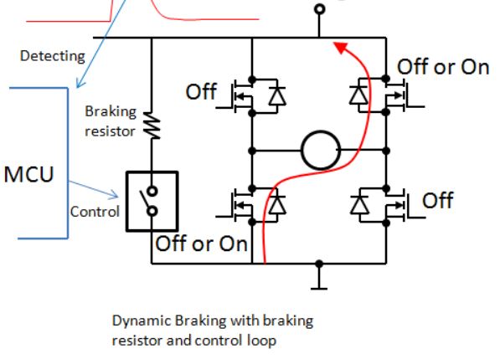

Figure 28: Dynamic Braking with External Resistor

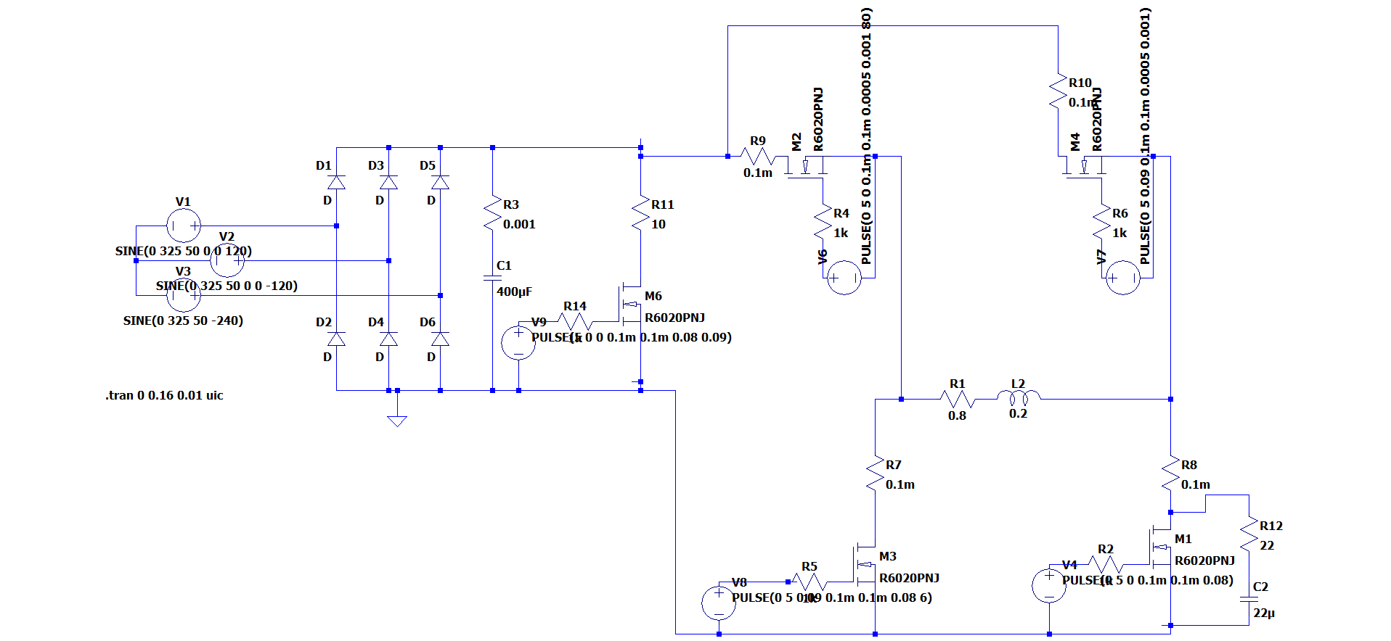

Figure 29: Schematic of H bridge

We tested slow motoring in forward direction and drive it reverse direction. Result shown at figure 30. While driving motor also Capacitor and IGBT stress measured.

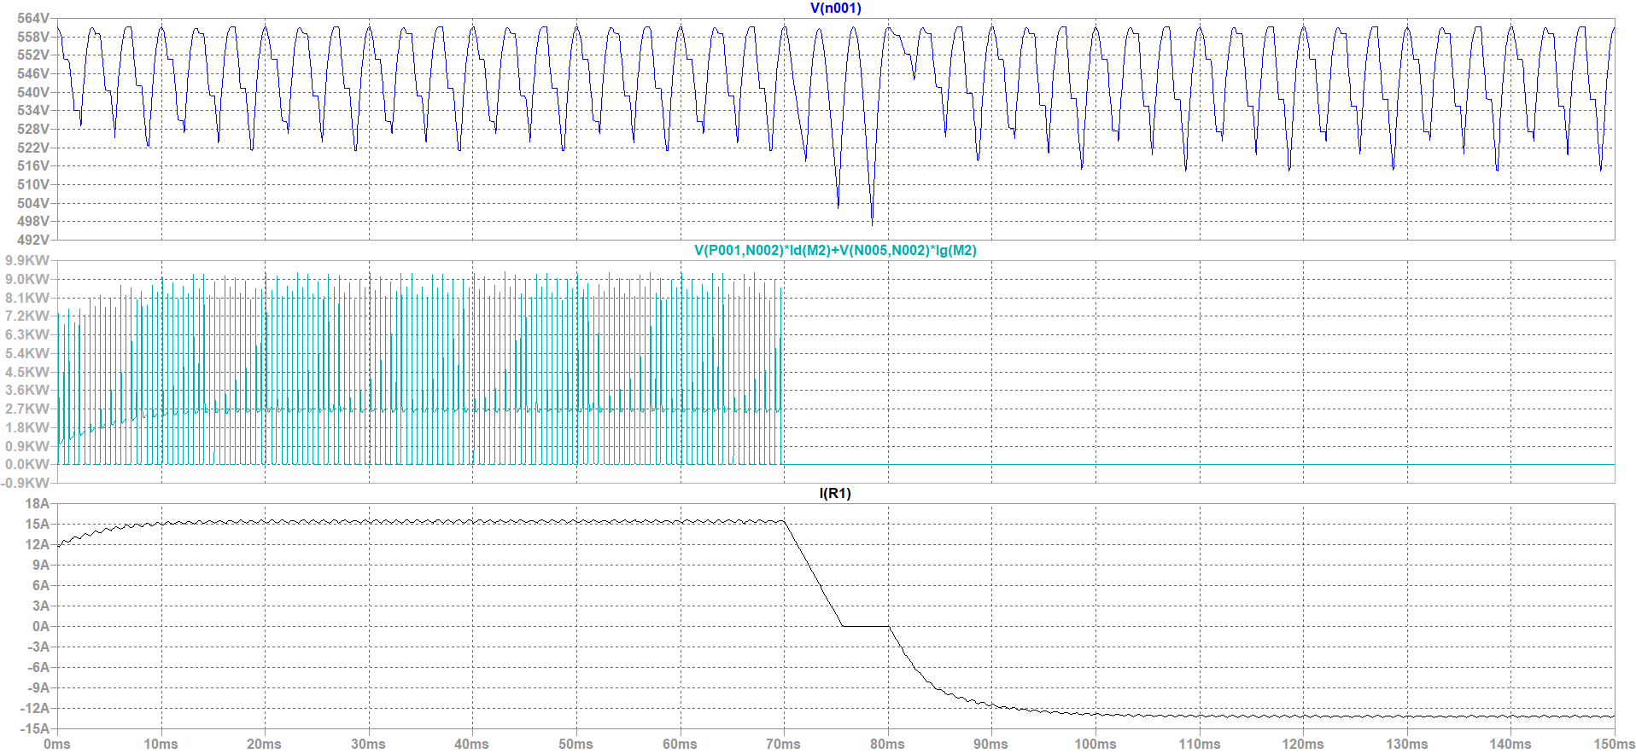

Figure 30: Capacitor voltage, IGBT stress and Motor current

İf we dont use dynamic Resistor Capacitor voltage is pump when slowing as shown at Figure 17.

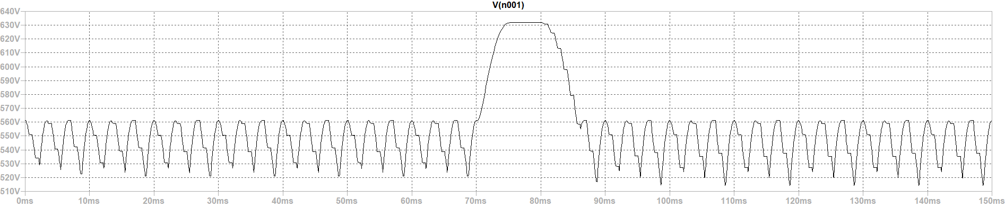

Figure 30: Capacitor voltage when there is no dynamic resistor

To use this H-bridge we also should use 5 TLP250 and 2 IGBT should be high side. At overall we dont have time to test this circuit.But we constructed it.

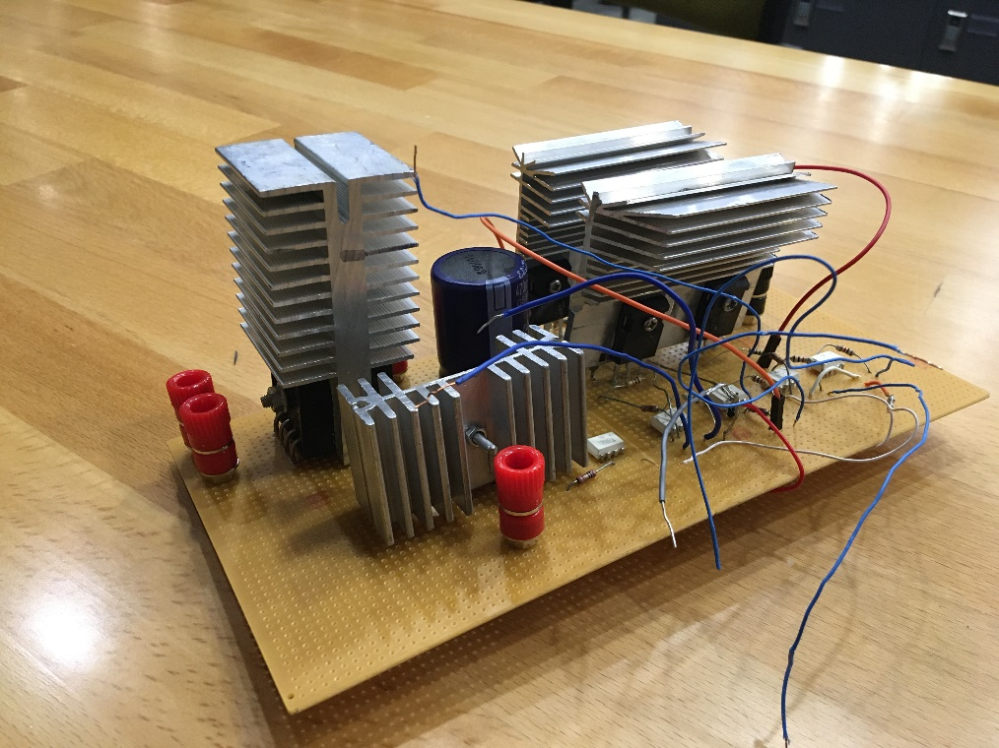

Figure 31: Constructed H-bridge circuit

### 3.3.2. PCB Implementation

PCB (Printed Circuit Board) is a circuit board which is widely used in every electrical and electronics area. At every professional circuit design, PCB design is inevitble. The reason for that are the connections of the components are copper paths, i.e. the connections are stationary and requires less volume, the components of PCB has less volume and it is more cost friendly when the circuit is massly producted. The copper paths are scraped to layers, i.e. the surfaces of the PCB. Depending on the complexity of the circuitry, the number of the layers may change, i.e. single-layer, double-layer, multi-layer. The more layer means it is more costy. So the less number of layers are used in PCB makes it more cost friendly. This project’s designed PCB is single layer since the circuitry is not complex. Of course, depending on the usage area, the shape and the volume of the PCB varies. For instance, according to the flowing current magnitude of a copper path, the wideness of the path changes. In other words, more current requires a wider copper path. The PCB design is made by considering these features and the design is made by using EasyEDA software as can be seen from the below figure;

1

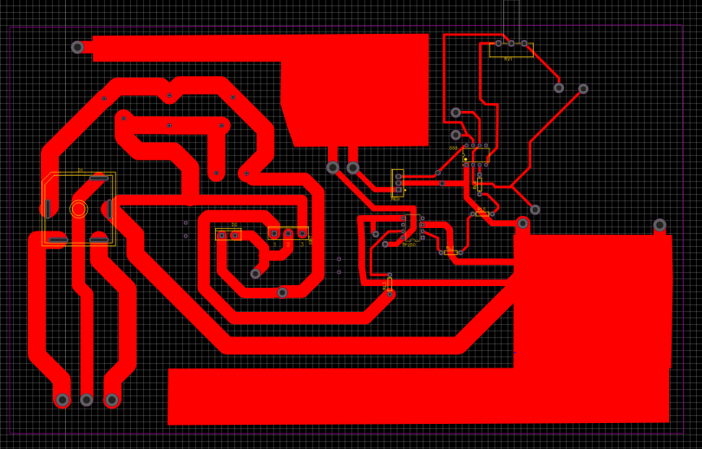

2

3

4

Figure 324:The PCB Design of DC Motor Drive

**1-**The copper areas that is used for positive DC voltage(Vcc) and ground(GND) connections. The reason for the huge amount of areas used is that the most current flowing areas of the circuit are DC supply and ground connections. If these does not have enough wideness the circuit may get damaged.

**2-**The connections of the 555 timer and octocoupler. The wideness of these connections are less relative to the left side of the circuit since it carries less amount of current.

**3-** The connections of the power electronics circuit, diode rectifier and buck converter. The wideness of these connections are greater relative to the left side of the circuit since it carries more amount of current.

**4-** The components. The components can be seen from Figure X easily by looking into the yellow edges except capacitors since they do not have an exact package type.

The routes (paths) wideness changes according to the the magnitudes of the current that is flown as mentioned before. The left side of the PCB, which can be seen from Figure X, is power electronics circuitry, i.e. diode rectifier, power mosfet, power diode etc. , and the right side of the circuitry is gate drive circuitry of the switching mosfet, i.e. octocoupler and 555 timer. So that is the reason for the difference between the paths wideness of right side and left side. Of course, the wideness of the paths are not determined blindly. According to the tickness of the copper routes ($oz/{ft}^{2}$) of the PCB, a calculation machine, a webside [x], is used in order to determine the size of the paths.

The components that is used in the circuit is determined before designing the PCB. So according to the choosen and bought components, the packages of the components are determined. However the capacitors does not have a certain package type. Therefore, the a package for these capacitors are not used. Instead, the measurement of the sizes of the capacitors are determined and the holes are placed fort he capacitors’ legs for implemeting capacitor places in PCB design.

The 3D wiev of the design and the ordered PCB can be seen from the Figure 33 and Figure 34.

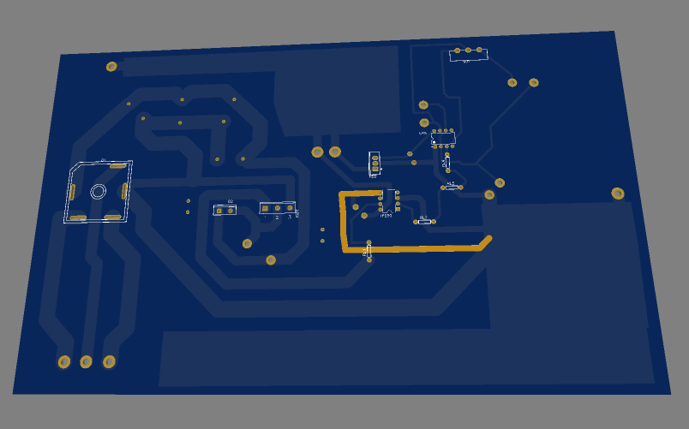

Figure 33:The 3D view of the PCB design

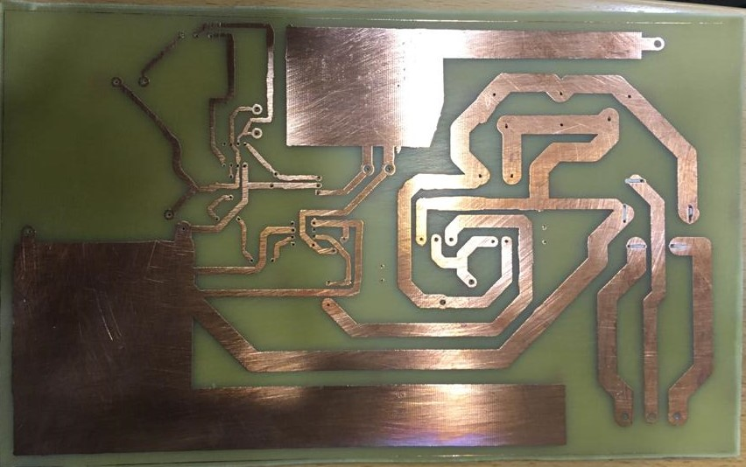

**Figure 34:**The PCB of the DC Motor Driver

The sizes of the PCB are 26 cm length,19.5 cm height and 2 mm thickness. Although it may seem huge, in order not to harm the circuit is much more important for this project. As in every application of engineering, if a feature of the design is developed, another feature needs to be waived. That is an example for this rule.

### 3.3.3. Industrial Box

The industrial box bonus is one of the simpliest bonuses. The designed circuit is placed in a box such that the circuit is stationary inside the box. In order to make it stationary, a couple of thoughts are discussed in M.P.W.U. team and decided to use slicon gun in order to make circuitry stationary. However due to the lack of time, it was not possible to place the circuit inside the box. Although, the box is not used at the demonstration, the design of it was completed as can be seen from the Figure X;

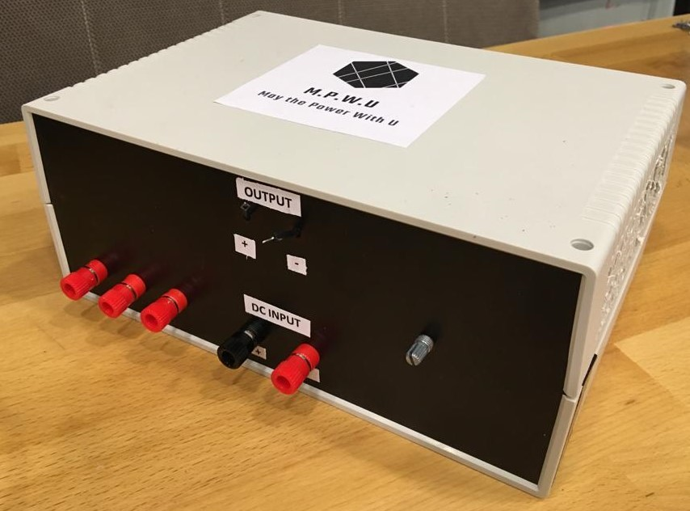

Figure 35:The view of the Industrial Box

The labels of input and output voltages are done. In addition to the input and output ports, the increase in the temperature of the circuitry is considered. A fan is placed inside the box but in order to keep the temperature under the control, the air circuilation was neccesary. So, sides of the box are drilled in order to achieve the air circulation.

### 3.3.4. Closed-loop Voltage/Current Control by Arduino

Since we could not complete that part,the design considerations will be explained but test results are not available. Firstly, the aim of controller design is making speed regulation and eliminating the disturbance on speed which can results from sudden torque changes like opening the kettle at some speed. To implement this firstly, we should have speed feedback that comes from the hall effect sensor (this is the only reason we could not implement controller because we could not get proper measurement from sensor instead we should have used optic encoder or voltage feedback which is directly proportional to speed) to obtain that we first try the simulink/arduino interface because in simulink the arduino library exist and also there are some special blocks that is designed for “RPM” measurement like “Tachometer” After measuring the speed we would want to make controller on the same environment because simulink has many control tools that makes easy for implement and no need for an embedded code that will perform the control task. However, we “Tachometer” block did not work in anyway. So, that strategy has been failed. As an alternative way, we tried to measure speed by an embedded code. In detail, code was working as follows, when a pulse is detected on the sensor the timer starts to count until the second pulse coming. That strategy had worked however measurement was not stable. To stabilize the measurement, we take the average of the last ten data as the speed data by that way, we achieve to measure. it worked but did not work at the demonstration. These operations are made on the arduino mega2560.

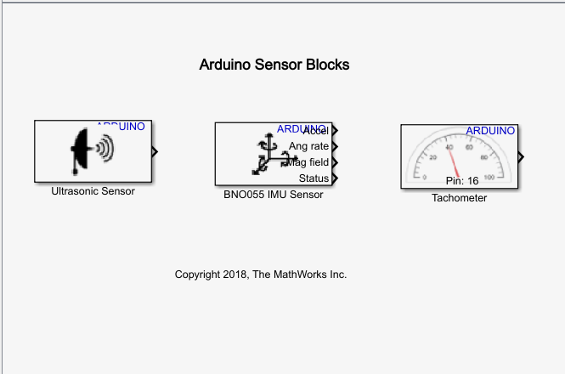

Figure36: arduino sensor library in simulink.

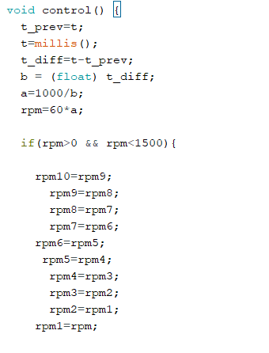

Figure37: some part of the the code (complete version is on the appendix.)

if we manage to measure the “RPM” earlier than we did, then we would make some test on the motor to extract some of the unknown parameters. Actually, in short we find directly to the transfer function of the motor by making “BUMP” test. In this method, we simply give motor to a Step input and observing the response. Since motor has 2 pole at the transfer function and also since one of the pole is extremely negligible compared to other pole, we can simply extract the transfer function, by finding the gain and response time of the system. However, since measurement has been failed we could not realize these.

# 5. Test Results

These datas are taken from the instants where the driver circuit is directly connected to the motor. In this part of the report, the current and voltage waveforms at various speeds of the motor will be observed.

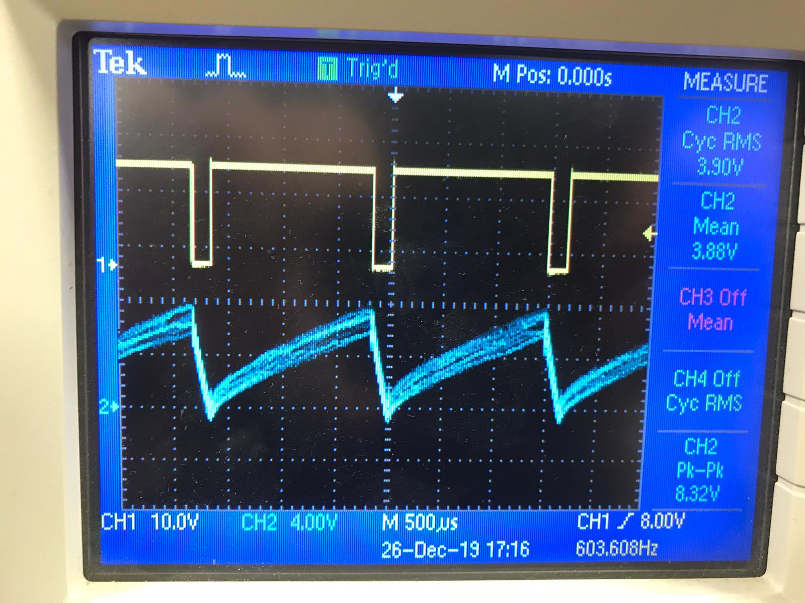

Figure38: the Armature current where the motor at rated speed at no load

* The armature current shape is like sawtooth because there is no additional inductor for filtering purposes
* It indicates that torque is changing always at the operation interval
* However, since the motor has its inertia like mechanic capacitor its speed does not change instantly and this inertia will keep speed almost constant during the periodic interval.

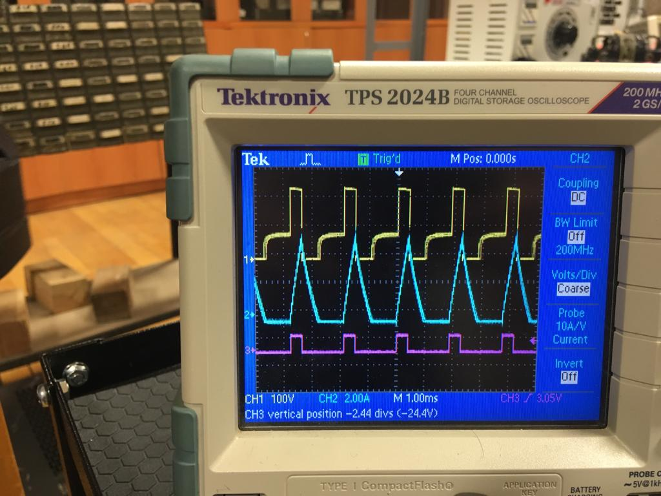

Figure39: motor is at 540 rpm(red:duty cycle,yellow:mosfet Vds, blue:armature current)

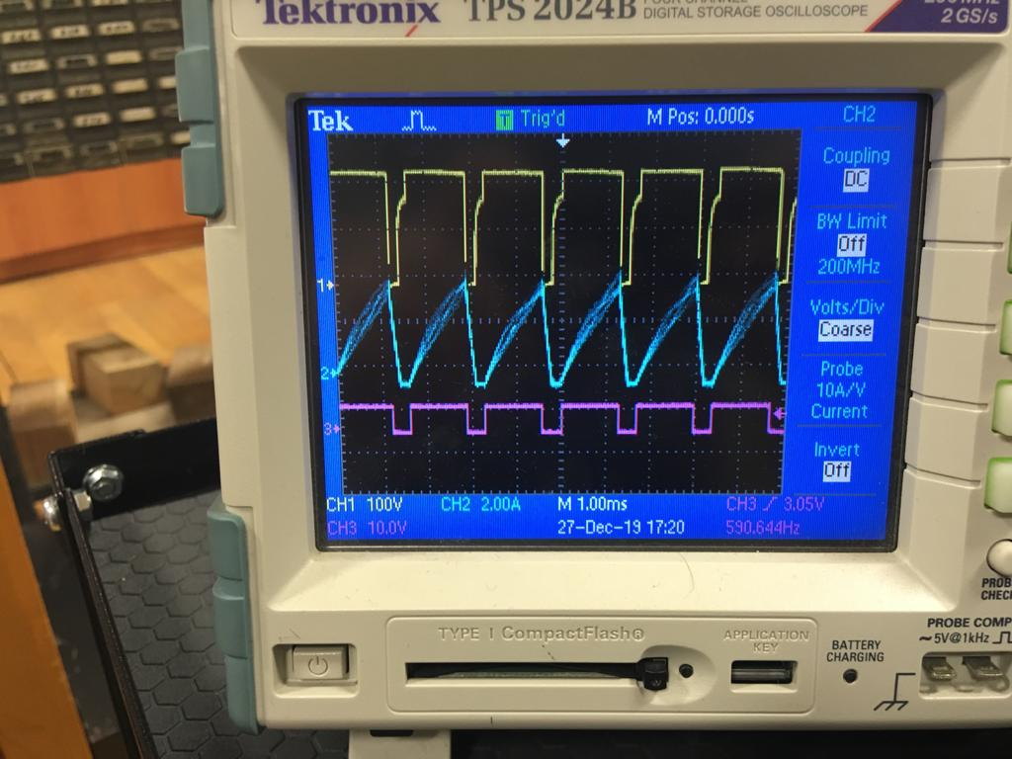

Figure 40: motor is at 800 rpm(red:duty cycle,yellow:mosfet Vds, blue:armature current)

* These are datas which are take from the motor at some speed and especially when it is discontinuous conduction mode.
* Since we do not have any inductor in the circuit we can not adjust the driver such that for all operating ranges of the duty cycle it will be in CCM.
* (***) The most interesting and nice waveform is belongs to mosfet (yellow ones) because since the driver is in DCM when the current of the inductor is zero and the mosfet gate signal is active in other words, when the mosfet is on and inductor current is zero “Back EMF” of the motor is directly seen from the mosfet drain node.

So, this is the reason why its voltage waveform makes horizontal constant voltages for a small amount of time.

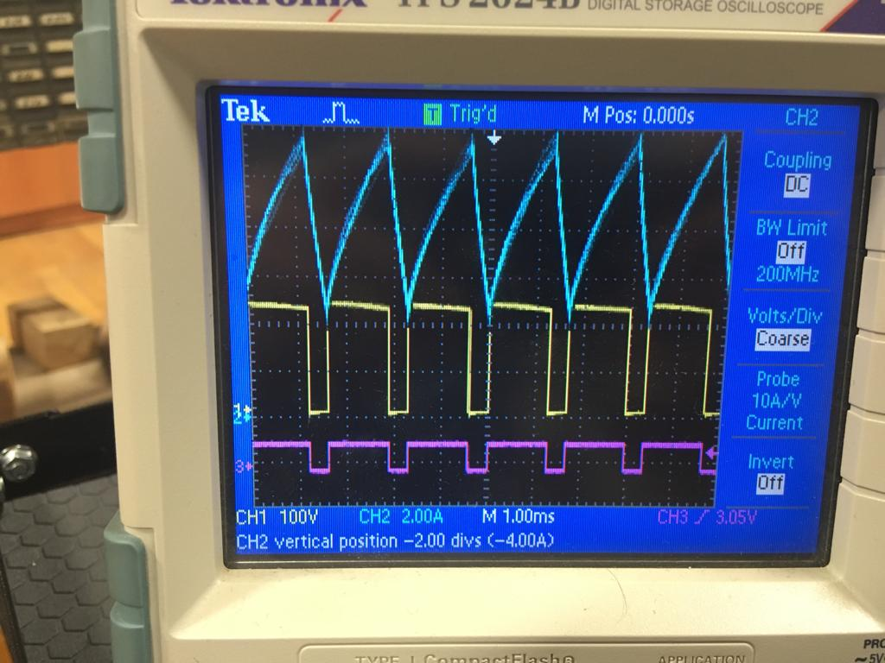

Figure 41: motor is at 1300 rpm and in continuous conduction mode

* Different from the DCM mode , there is no back emf seen from the mosfet drain node.

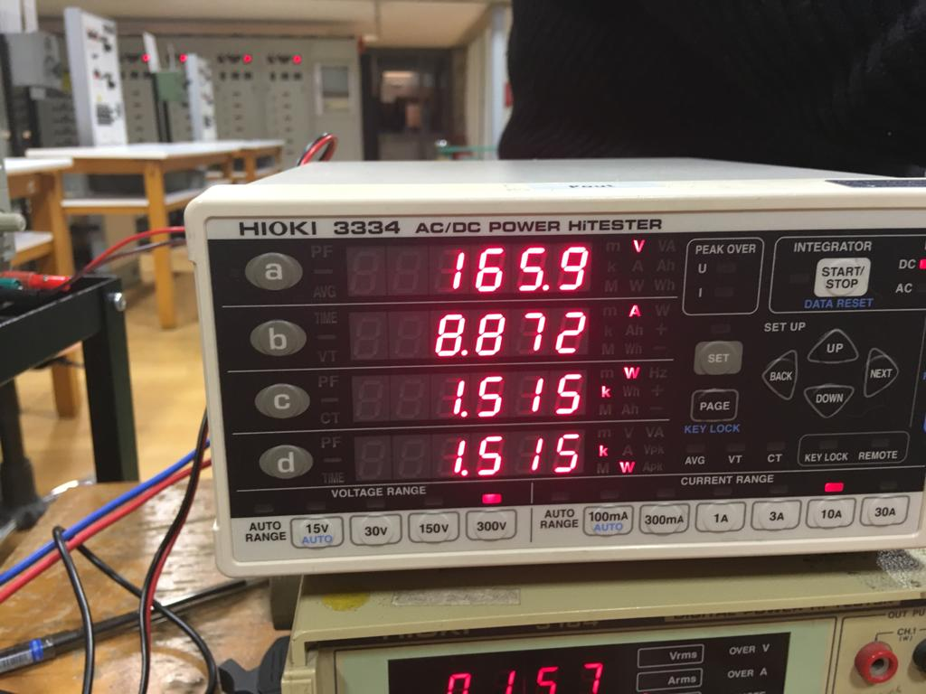

Figure42: motor power output and output current (resistive load case)



Figure43: motor is at loaded with the kettele and the current is huge now (900 RPM)

* When the resistive load is connected there will be torque disturbance at the load and this will decrease speed since more torque is required to drive this new load.
* When the torque is increased the current also be increased and it reaches like 8-9 amperes.

# 4. Conclusion

The electrical machines has a huge part in our lifes. They are used in a wide area from generating power to electrical vehicles. In order to use these devices, it is compulsary to design and use their driver circuits. These driver circuits are combinations of different topologies from different usage areas such as control engineering, power electronics engineering, electronics engineering etc. So this project’s scope consists of these driver circuits. The driver circuit of a DC motor is designed by determining the simpliest topology, invetigating it and designing it with a full understanding of these topologies. As DC motor drive, three phase diode rectifier is used in order to convert AC voltage of variac and buck converter is used in order to control the DC voltage that is applied to DC motor. The switching MOSFET that is a part of buck converter required a driver circuit as well. In order to drive the gate of the MOSFET, i.e. a PWM(pulse width modulation) signal is used in order to arrange the level of DC voltage applied by the duty cycle raito, 555 Timer circuit and octocoupler circuit is used. Although only a single bonuses’ point is earned, almost every bonus is tried to be implemented. The reason for not to achive these bonuses is the lack of time for the demonstration. However, these bonuses were quite instructive and become a good practice. Additionally, this project has a good contibution to team work skills and the design steps from investigating to implementing.

# 5. References

Retrived from : <https://www.aliexpress.com/i/32634872516.html>

Retrived from : <https://www.instructables.com/id/DIY-High-Current-Motor-Driver-h-bridge/>

Retrived from : <https://e2e.ti.com/blogs_/b/industrial_strength/archive/2013/10/18/the-art-of-stopping-a-motor>

Retrived from : <https://pdf.direnc.net/upload/ixgh24n60c4d1-datasheet.pdf>

Retrived from : <http://ixapps.ixys.com/DataSheet/DHG30I600PA.pdf>

Retrived from : <https://www.aliexpress.com/i/32634872516.html>

# 6. Appendix

volatile int rpmcount = 0;

unsigned long t_prev = 0;

unsigned long t = 0;

unsigned long t_diff = 0;

unsigned long lastmillis = 0;

float rpm=0;

float a=0;

float b=0;

int ti=0;

float desired_rpm=0;

int duty=0;

int c=0;

float rpm1=0;

float rpm2=0;

float rpm3=0;

float rpm4=0;

float rpm5=0;

float rpm6=0;

float rpm7=0;

float rpm8=0;

float rpm9=0;

float rpm10=0;

volatile float rpm_overall=0;

void setup() {

Serial.begin(9600);

pinMode(11, OUTPUT);

attachInterrupt(0, control, FALLING);

}

void loop() {

if (millis() - lastmillis >= 400){

if(rpm_overall>600){

lastmillis=millis();

desired_rpm=analogRead(0);

desired_rpm=desired_rpm*1.5;

if(desired_rpm-rpm_overall>

10)

{

if(duty<255){

duty=duty+1;

}

analogWrite(11,duty);

}

else if(rpm_overall-desired_rpm>10)

{

if(duty>0){

duty=duty-1;

}

analogWrite(11,duty);

}

}else{

duty=analogRead(0);

duty=duty/4;

analogWrite(11,duty);

}

}

}

void control() {

t_prev=t;

t=millis();

t_diff=t-t_prev;

b = (float) t_diff;

a=1000/b;

rpm=60*a;

if(rpm>0 && rpm<1500){

rpm10=rpm9;

rpm9=rpm8;

rpm8=rpm7;

rpm7=rpm6;

rpm6=rpm5;

rpm5=rpm4;

rpm4=rpm3;

rpm3=rpm2;

rpm2=rpm1;

rpm1=rpm;

rpm_overall=(rpm1+rpm2+rpm3+rpm4+rpm5+rpm6+rpm7+rpm8+rpm9+rpm10)/10;

Serial.println(rpm_overall);

}

}